Full Charge Range Report –PHEV- CGEA 1.3

Functional Description

The Full Charge Report is an Information On Demand (IOD) screen. The information displayed shall contain the following information:

- Rated Range
- Driving Impact on Range
- Climate and other Impact on Range
- Expected Range
Full Charge Report screen is used to inform the driver about Expected Range with impact of driving and environment. Full Charge Report consists of four items of information. Full Charge Report shall include Range per full charge, Driving Impact on Range, Climate and other Impact on Range, Expected Range values based on the signals provided by the powertrain controls.

Full Charge Report correlates the inputs of RngPerChrgLbl_L_Dsply, RngImpctDrv_L_Dsply, RngImpctClim_L_Dsply, RngPerChrgAvg_L_Dsply and Display_Units_MC to generate a graphic to provide Range information to driver.

THIS STSS HAS BEEN OBSOLETED. THIS FEATURE IS NO LONGER REQUIRED AS DATA ON THIS SCREEN CAN MISLEAD THE DRIVER.

Interfaces

Interface Context Diagram (I/O Block Diagram)
Figure 1.1 Full Charge Report Context Diagram

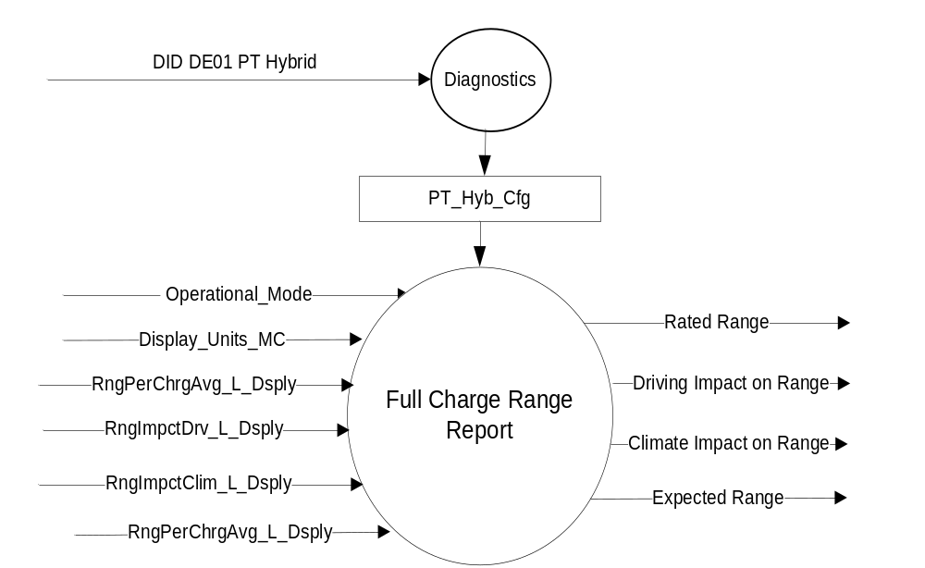

Inputs
- INTERNAL:
  - Operational_Mode
  - Display_Units_MC
- MUX messages on the CAN Bus

- CAN Input Signals
Signal Name | Size (bits) | Detail | Units | Res. | Offset | State  Encoded | Min | Max
RngPerChrgLbl_L_Dsply | 12 |  | km | 0.1 | 0 |  | 0 (0x0) | 409.3 (0xFFD)
 |  | NoDataExists |  |  |  | 0xFFE
 |  | Faulty |  |  |  | 0xFFF
RngImpctDrv_L_Dsply | 12 |  | km | 0.1 | 0 |  | 0 (0x0) | 409.3 (0xFFD)
 |  | NoDataExists |  |  |  | 0xFFE
 |  | Faulty |  |  |  | 0xFFF
RngImpctClim_L_Dsply | 12 |  | km | 0.1 | 0 |  | 0 (0x0) | 409.3 (0xFFD)
 |  | NoDataExists |  |  |  | 0xFFE
 |  | Faulty |  |  |  | 0xFFF
RngPerChrgAvg_L_Dsply | 12 |  | km | 0.1 | 0 |  | 0 (0x0) | 409.3 (0xFFD)
 |  | NoDataExists |  |  |  | 0xFFE
 |  | Faulty |  |  |  | 0xFFF

Outputs
- Rated Range
- Driving Impact on Range
- Climate and other Impact on Range
- Expected Range

Function/Performance

Operational Modes

Mode | Differentiating Vehicle Conditions
Sleep Mode | Full Charge Range Report Off
Limited Mode | Full Charge Range Report Off
Normal Mode | Full Charge Range Report Functioning
Crank Mode | Full Charge Range Report Functioning

Voltage Levels

Refer to Cluster Features table located in Operational Modes and Voltage Range Strategies Section in this SPSS.

Human-Machine Interface

Visual

Indicator Graphics / Display Format
Full Charge Range Report screen layout

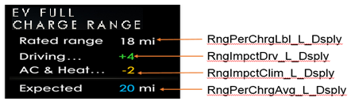

Above are example graphics.
Actual graphics are to be provided by Ford HMI or Studio and approved by the DI Application for each program.

Indicator Color Coordinates

Reference Ford HMI or Studio Wallpaper files for the specific program.

Indicator Characteristics

Reference Ford HMI or Studio Wallpaper files for the specific program.

Audio

None

Switch Control Logic

None

System Accuracy

Within a 100msec of receiving a message that results in a change of state the cluster will update the display to the proper status.

Operation: Performance and Functional

Subsystem Algorithm Flowchart / State Diagram

Figure 1.2 EV Full Charge Range Components

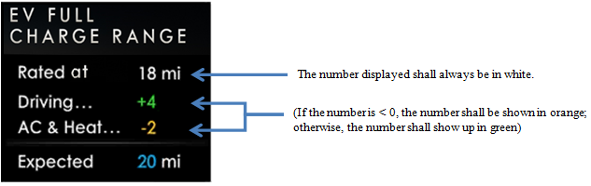

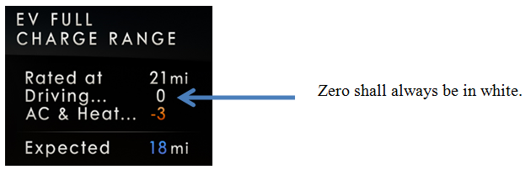

Operation Description (supports algorithm flowchart /state diagram)

The Full Charge Range Report shall include an Rated Range, Driving Impact on Range, Climate other

Impact on Range, Expected Range as per full charge.

If a number is shown on the display, it shall be a whole number only (due to not wanting to imply precision and graphic space constraints).

The rated range shall be displayed as white while the impact of driving and climate shall be shown with Green and Orange colors. For Driving and Climate impact below is the color coding :

If the number is less than Zero it should be presented in Orange

If the number if greater than Zero should be presented in Green

If number is Zero should be presented in White.

During key off, the information displayed for Ranges shall not be updated (i.e. the key off displays are static, even if the CAN signal values change)

In case of missing signals for RngPerChrgAvg_L_Dsply, RngImpctDrv_L_Dsply, RngImpctClim_L_Dsply, RngPerChrgAvg_L_Dsply display dashes “- -” for its value.

Function Safety Classification (EMC)

Class B

Memory Storage
Parameter Name | Description | Value at Battery connect | Value at  Module Wake-up
RngPerChrgLbl_L_Dsply | CAN Input for Rated range | 0 | Do Not Init
RngImpctDrv_L_Dsply | CAN Input for Driving Impact on Range | 0 | Do Not Init
RngImpctClim_L_Dsply | CAN Input for Environment impact on Range | 0 | Do Not Init
RngPerChrgAvg_L_Dsply | CAN Input for Expected Range | 0 | Do Not Init
Rated Range | Output of Rated Range | 0 | 0
Driving Impact on Range | Output of Driving Impact on Range | 0 | 0
Climate Impact on Range | Output of Environment impact on Range | 0 | 0
Expected Range | Output of Expected Range | 0 | 0
Display_Units_MC | Input to this routine that controls display indicating units to the driver (i.e. when English: miles, mpg; when Metric: km, L/100 km, km/L). Parameter is to be stored in Battery Backed RAM. | Used Stored Value (See Display Unit Selection Control Function STSS) | Do Not Init
Operational_Mode | Input to this routine that is a 4 State indicator for cluster operational mode | As per Operational Modes and Voltage Range Strategies Section (STSS) | As per Operational Modes and Voltage Range Strategies Section (STSS)

Prove Out

Not applicable.

Reconfigurable Telltale

Not applicable.

Message Center Msg

Refer to text as defined in the Text Translation file

Error Handling

Missing Message Strategy

The signals will be declared missing as per the Diagnostics section of this SPSS.

DTCs states and history will be determined as per the Diagnostics section of this SPSS.

Invalid Data Strategy

As per system flowchart.

Diagnostics

Self Test

None

Engineering Test Mode

Reference section “Dealer / Engineering Test Mode (ETM)”

Part II Performance

Supported Diagnostic Trouble Codes (DTCs)
DTC | Description
C29300 | Lost Communication with Hybrid/EV Powertrain Control Module
C59400 | Invalid Data Received From Hybrid/EV Powertrain Control Module

DID DExx - None

Reference Specification
IS-0344 GENERAL REQUIREMENTS (MSGCENTR)
IS-0379 NORTH AMERICAN WARNINGS AND INDICATORS STRATEGY

- Manage EV Display_PHEV – CGEA1.3 STSS
- Appropriate Program Specific Text Translation File
- Appropriate Program Specific IPC Menu Structure File

Revision History

SPSS Module Revision History

Revision Level | Name | Change Description | Date
1.0 | H. Sharma | Initial Release | 9/13/2017
1.1 | H. Sharma | Feature Obsoleted | 23/03/2018

